Optimize logistics with the control module falconic
Manage and organize simply the container pool
Grieskirchen January 2018 Pöttinger waste disposal technology has developed a control module which facilitates a company in combination with a SIM-card and corresponding web interface to organize all processes for the container pool from emptying to maintenance and thus to reduce costs. Pöttinger introduces the falconic system at the IFAT 2018 in Munich.

An essential aid for an effective work organisation – at the heart of a tool
Pöttinger waste disposal technology presents on its booth 315/ 414 in hall A5 the new control module falconic. As producer of different press systems the company offers its clients sustainable and tailor-made product solutions for the collection of recyclable fractions and residual waste which contribute essentially to reduce transport and logistic costs. To make a step further the module was integrated in the press container. Thereby all information about relevant machine functions can be gained and used for optimizing logistics and scheduling the containers. Also companies with a mixed machine pool are able to use it as falconic may also be integrated in machines from other manufacturers.
The falconic control module has lots of advantages by the communication with the press container. Automatic detection and adaptation of the rotating field, filling level detection and most modern standard in safety engineering are the basics.
Combined with a SIM-card, the system offers lots more possibilities: by GPS tracking and visualization of the container positions on the falconic website, the client gets an overview on his container pool and by that he is able to optimize scheduling and transport routes. All data is available to the user by means of a login and password. The automatic filling level announcement form the press replaces the report requirement by the operator. With this, it is possible to plan collections in good time and reduce reaction times. With falconic, the containers can be optimally managed in the web interface by information about the container status in real time. In this way, the containers are utilized at is best and costs are reduced. Also maintenance costs are reduced as the machines are configured online and an automatic maintenance message can be set.
Online configuration of machines and installation site
The scheduler is informed by email or SMS of the filling level, location and any error messages from the machines. An arbitrary time point for all status messages can be chosen. Additionally it is possible to store individual settings for each installation site for the respective material usage, press position or amount of strokes. When the containers are exchanged the new machine will take over automatically the settings of the installation site. Furthermore it is possible to generate statistics to all information related to the machine as amount of emptying, starting sequences, error messages and so on.

Connection to existing systems possible
As an essential advantage it may be indicated that falconic may be connected to already existing scheduling and invoicing programs. Thus machines and transport vehicles can be organized together. Furthermore it is possible to regulate the access to the falconic website according to the user. Also access control to press containers are easily realized.
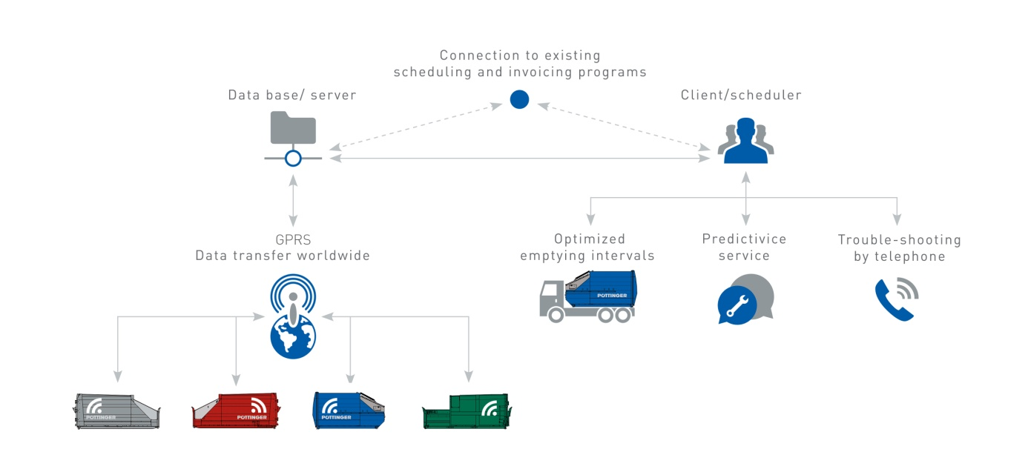
Everything from a single source
Pöttinger waste disposal technology got more than 15 years experience in the field of online data processing programs by the deployment of WIP. This is used with the MULTIPRESS ECO, a modern waste disposal system which provides comprehensive complete solutions for housing associations and cities in the field of the household waste disposal according to the principles of cause and responsibility. In the future Falconic will replace WIP. So the client always gets a complete system comprising press containers, online data processing program as well as provision of services.

You will find all press information and photos at: www.poettinger-oneworld.at/press

